SIGNALS AND SYSTEMS
Course Code: ECA0305
CO1 – EXPERIMENT 1
Experiment 1.1
Title: Generation of Continuous Time Signals
Aim:
To generate and plot a continuous-time sinusoidal signal with a specified frequency, amplitude and phase shift using MATLAB, and to identify its basic parameters.
Apparatus Required:
- Personal computer
- MATLAB software
Procedure:
- Open MATLAB and create a new script file.
- Clear the command window and workspace using clc, clear and close all.
- Define the continuous time axis t using a small step size (t = -5:0.01:5).
- Generate the continuous-time sine signal x = sin(2*pi*t).
- Plot the signal using the plot command with grid, title, xlabel and ylabel.
- Run the program and observe the waveform.
- Note the amplitude, frequency and time period from the plotted output.
Program:
% Generation of Continuous Time Signals
clc;
clear;
close all;

% Time axis
t = -5:0.01:5;

% Continuous-time sine signal
x = sin(2*pi*t);

% Plotting
figure;
plot(t, x, 'LineWidth', 2);
grid on;
title('Continuous Time Sine Signal');
xlabel('Time (seconds)');
ylabel('Amplitude');
Output – Experiment 1.1:
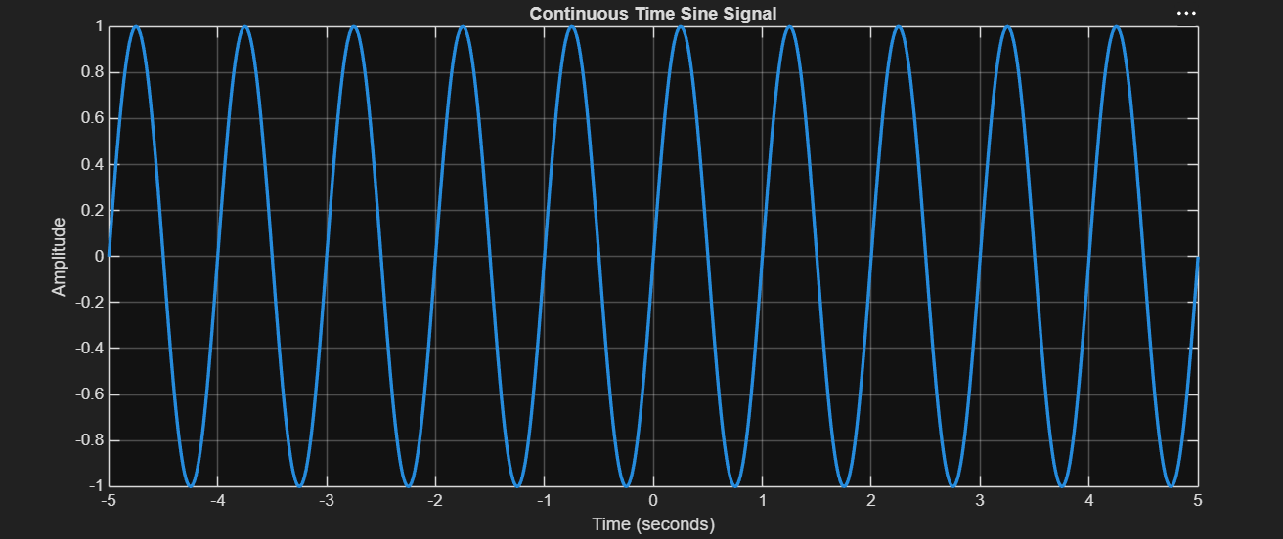

Result:
This test case validates that the signal generator can produce a sinusoidal waveform with the
specified frequency, amplitude, and phase shift.

Experiment 1.2

Title: Generation of Discrete Time Signals
Aim:
To generate and plot a discrete-time sinusoidal sequence using MATLAB and to observe its representation as individual samples.
Apparatus Required:
- Personal computer
- MATLAB software
Procedure:
- Open MATLAB and create a new script file.
- Clear the command window and workspace using clc, clear and close all.
- Define the discrete-time index n = -10:10.
- Generate the discrete-time sinusoidal sequence x = sin(0.2*pi*n).
- Plot the sequence using the stem command with grid, title, xlabel and ylabel.
- Run the program and observe the stem plot.
- Note the amplitude and sequence length from the output.
Program:
% Generation of Discrete Time Signal
clc;
clear;
close all;

% Discrete-time index
n = -10:10;

% Discrete-time sinusoidal signal
x = sin(0.2*pi*n);

% Plotting
figure;
stem(n, x, 'filled');
grid on;
title('Discrete Time Sinusoidal Signal');
xlabel('Sample Index (n)');
ylabel('Amplitude');

Output – Experiment 1.2:

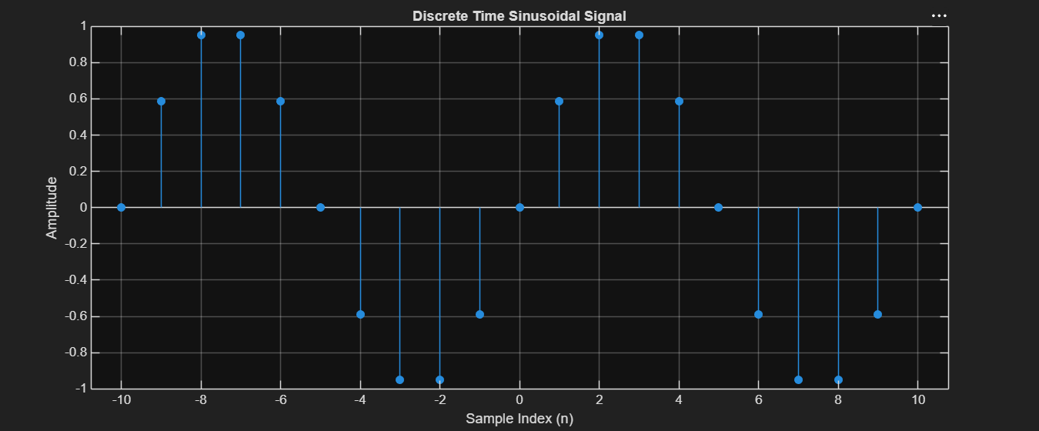

Result:
This test case validates that the signal generator can accurately produce a discrete-time unit
impulse signal at a specified index, which is essential for analyzing the response of discrete
time systems.

LABORATORY PERFORMANCE ASSESSMENT RUBRICS:

Objective | Assessment Criterion | Excellent – 4 | Good – 3 | Satisfactory – 2 | Needs Improvement – 1 | Weightage | Marks(10) | Marks obtained
1. Generate and visualize basic continuous-time signals such as unit step, unit impulse, ramp, sinusoidal and exponential. | CT Signal Generation & MATLAB Implementation | Generates all five CT signals accurately with a suitable time vector and step size. Uses correct MATLAB commands . Plots are correctly scaled, with titles, axis labels and grid. | Generates the required CT signals and plots correctly, with minor errors in code, time range, parameters or labelling. | Generates basic CT signals but has noticeable errors in code, step or impulse representation, or plots, and needs assistance. | Unable to generate the required CT signals or produce meaningful plots. | 25 | 2.5
2. Generate and visualize basic discrete-time signals such as unit sample, unit step, ramp, sinusoidal and exponential sequences. | DT Signal Generation & MATLAB Implementation | Generates all five DT sequences accurately with a proper index vector n. Uses stem correctly. Plots are correctly scaled, with titles, axis labels and grid. | Generates the required DT sequences and plots correctly, with minor errors in index range, stem usage, parameters or labelling. | Generates basic DT sequences but has noticeable errors in code, indexing or stem plots, and needs assistance. | Unable to generate the required DT sequences or produce meaningful stem plots. | 25 | 2.5
3. Classify CT and DT signals as periodic or aperiodic and identify their waveform characteristics. | Signal Classification & Periodicity Analysis | Correctly classifies all signals using DT. Determines the period where applicable. Identifies frequency, phase, and growth or decay. Explains the reasoning clearly with mathematical conditions and waveform evidence. | Classifies most signals correctly and finds most periods, with minor errors or limited justification. | Gives basic classifications. Period calculation or justification is incomplete and needs guidance. | Unable to classify the signals correctly or justify the classification. | 25 | 2.5
4. Analyze the amplitude and time-index characteristics of discrete-time signals. | Amplitude & Time-Index Analysis | Correctly determines maximum and minimum amplitude, the index n at which each occurs, and signal energy. Correctly shows the effect of time shifting and folding on the index. Interprets the results clearly. | Analyzes most amplitude and index characteristics correctly, with minor errors in values or interpretation. | Gives basic amplitude and index analysis with noticeable errors, and needs guidance. | Unable to analyze the amplitude and time-index characteristics or interpret the results. | 25 | 2.5
 |  |  |  |  | Total | 100 | 10

